CSY1018 PROJECT REPORT

Web Development

Prashanta Upreti

UN ID=17425083

Table of Contents

1 Github Link 2

2 Path to Portfolio. 2

2.1 Beginning 2

3 . Designs 2

3.1 Sketches 2

3.1.1 Sketches of Homepage(Index). 2

3.1.2 Sketch of the Biodata 3

3.1.3 Sketch of the CV (Curriculum Vitae). 4

3.1.4 The sketch of the Contact Paper. 5

4 Wireframes 6

4.1 Wireframe of Homepage(index). 6

4.2 Wireframe of Biodata. 7

4.3 Wireframe of CV. 8

4.4 Wireframe of Contact. 9

5 Comparison the two websites. 10

6 . Progression of Website from Week 8 to Week 11. 11

6.1 Week 8 (Beginning of the project work.) 11

6.2 Week 9 13

6.3 Week 10 14

6.4 Week 12 15

6.5 Week12 16

7 Evidence That Proves It Is Reliable website 16

7.1 Page Load Speed(Website speed,2017) 16

7.2 Prove of Html and CSS Validator(The W3C CSS,2017) 17

8 Problems 22

9 Solution 23

10 Before and as per Suggestion of the Tutor. 24

11 Conclusion 26

11.References 26

# Github Link

<https://github.com/prashantaupreti2054/csy1018-assignment>

<https://prashantaupreti2054.github.io/csy1018-assignment/>

# Path to Portfolio.

## Beginning

Before starting the project of my portfolio, I do research and have a view of other people portfolio from different site but later I started with reading the requirements description of the project afterward I spent most of the day on designing on the home page of the portfolio. Started with the design of the menu bar and color combination was part to be remember. A lot of color was used in the page which wasn’t too much eye blinking after color combination was changed. Black and white were used for the background of the portfolio and grey color was used as text color in the whole project. After the completion of the 12 week I could design the project of the portfolio.

<http://www.creativebloq.com/portfolios/examples-712368>

<https://joel.sh/about>

<https://www.w3schools.com/>

# . Designs

## Sketches

### Sketches of Homepage(Index).

Homepage of the sketches is one of the most important things, coming all way from the project. Firstly, navigation bar was the stuff to be completed. In the menu bar home, cv, bio, contact may be the option after the going through the homepage. I will complete my body by adding the photo and concise description about myself in the left bar and the right bar. In the footer as the message keep in touch will be shown as the heading and after that location of the place will be kept below with phone number. Finally, I will keep link of Facebook, Instagram and yahoo. I would like to use CSS like the margin, flex will be for proper design. 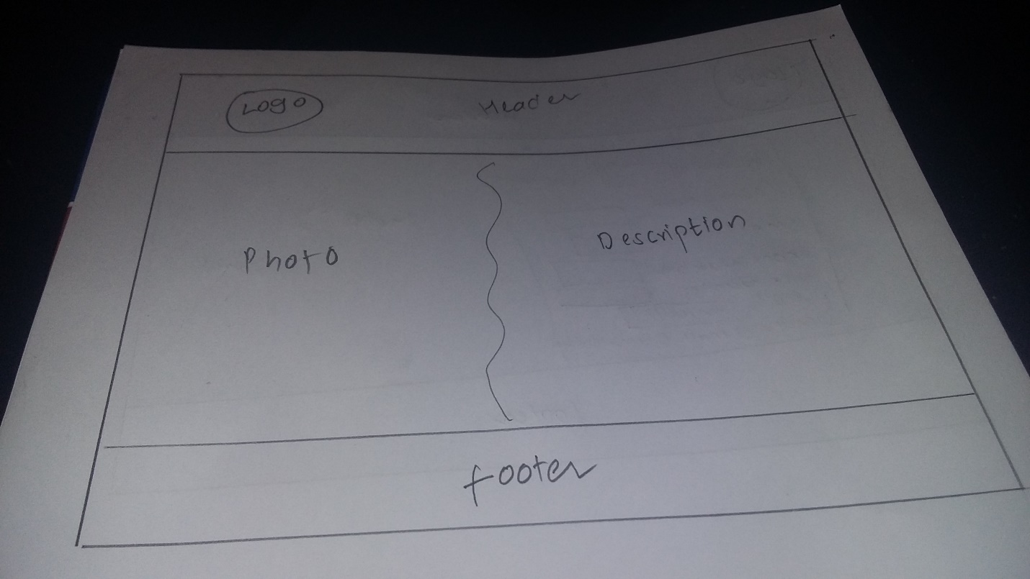

### Sketch of the Biodata

The color combination will be same as of the homepage. Black, white and grey which will be helpful to match the color of the bio page and the homepage. Firstly

header will be similar containing the logo after that it will also contain the menu bar. secondly the body will contain two part in this page under the same section in this page two division will be done. One division will contain image and another division will contain my biography and in the biography heading will be given as ‘about myself’. Finally, footer will be same as like in home page, it will contain two division one will show the link of social media page and another division will show the location and my mobile number.

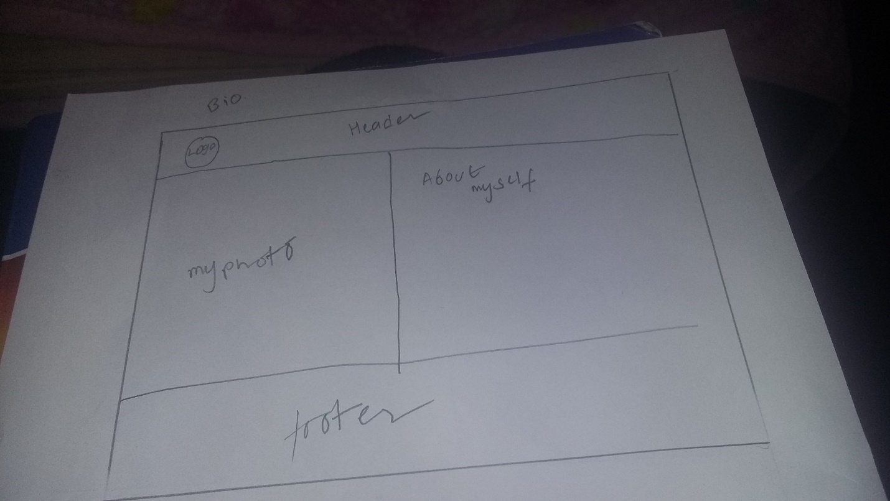

### Sketch of the CV (Curriculum Vitae).

The page main content will contain detail about the education and experiences So, it is named as Curriculum vitae. The header will contain the menu bar and logo. Color combination for this page will be same black, white and grey. Body part contain section under that section there will be three division and first division will contain image and remaining two division will contain education and experience respectively. The footer will contain the location and the detail of the mobile number and another division will contain the link of the social media like Facebook and other.

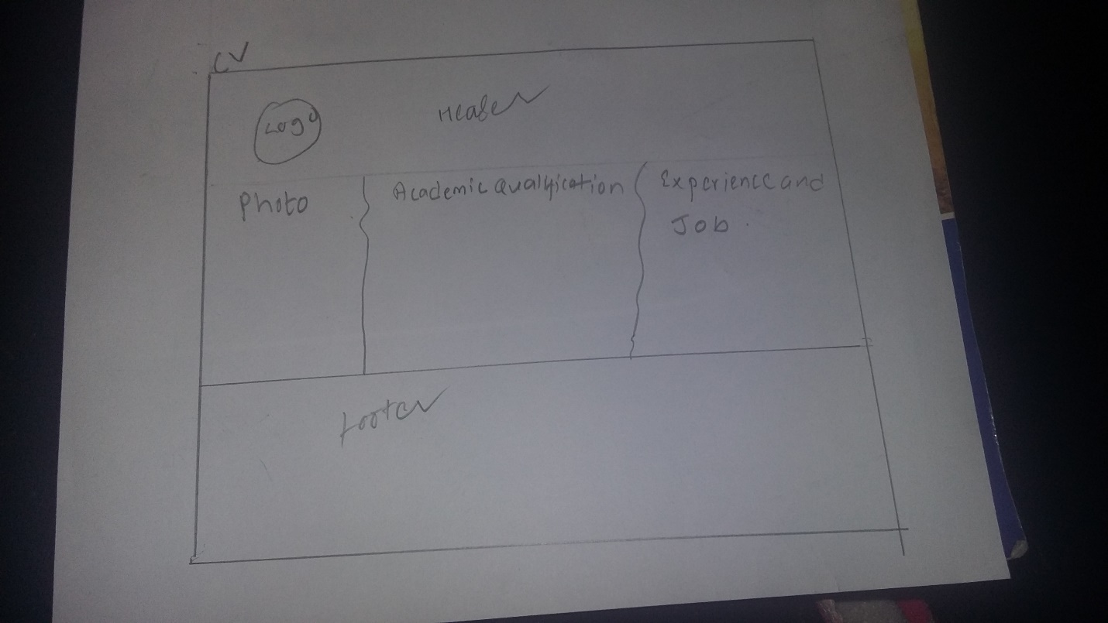

### The sketch of the Contact Paper.

The contact page will contain the form for the people who are interested to join like to do friendship and form like name, email, and other information will be given in the body section of this page. The header will be same it will contain two division like logo and menu bar. The body will also contain two division one section will contain the image and another will contain the form. The footer will contain the two division under the same section one division will contain the detail of location and another division will contain the social media like Facebook, yahoo and other.

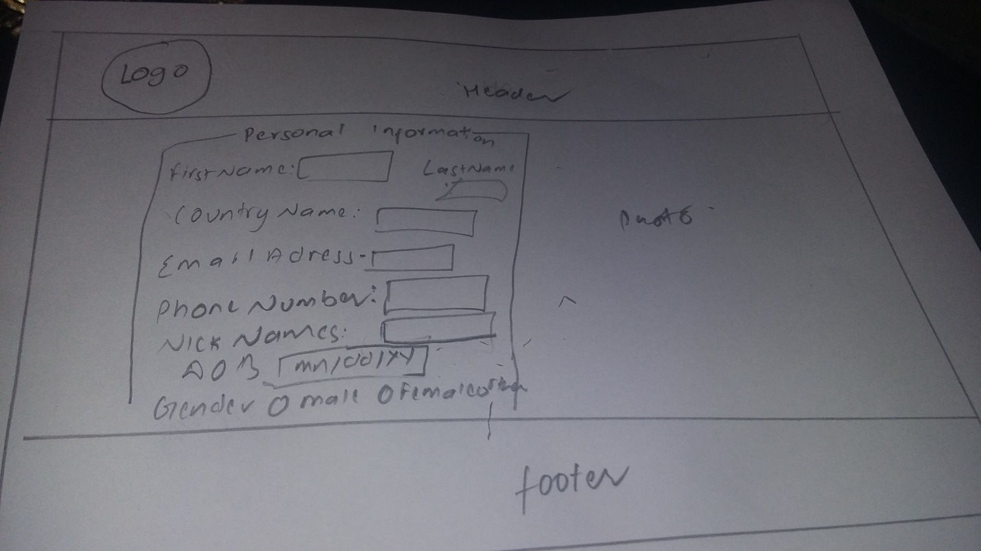

# Wireframes

## Wireframe of Homepage(index).

This is the first wireframe I create it consists of the simple system like the like one logo menu bar and the body part contain the division one for the image and another for the for the description and footer.

Figure: The figure is wireframe of the Homepage

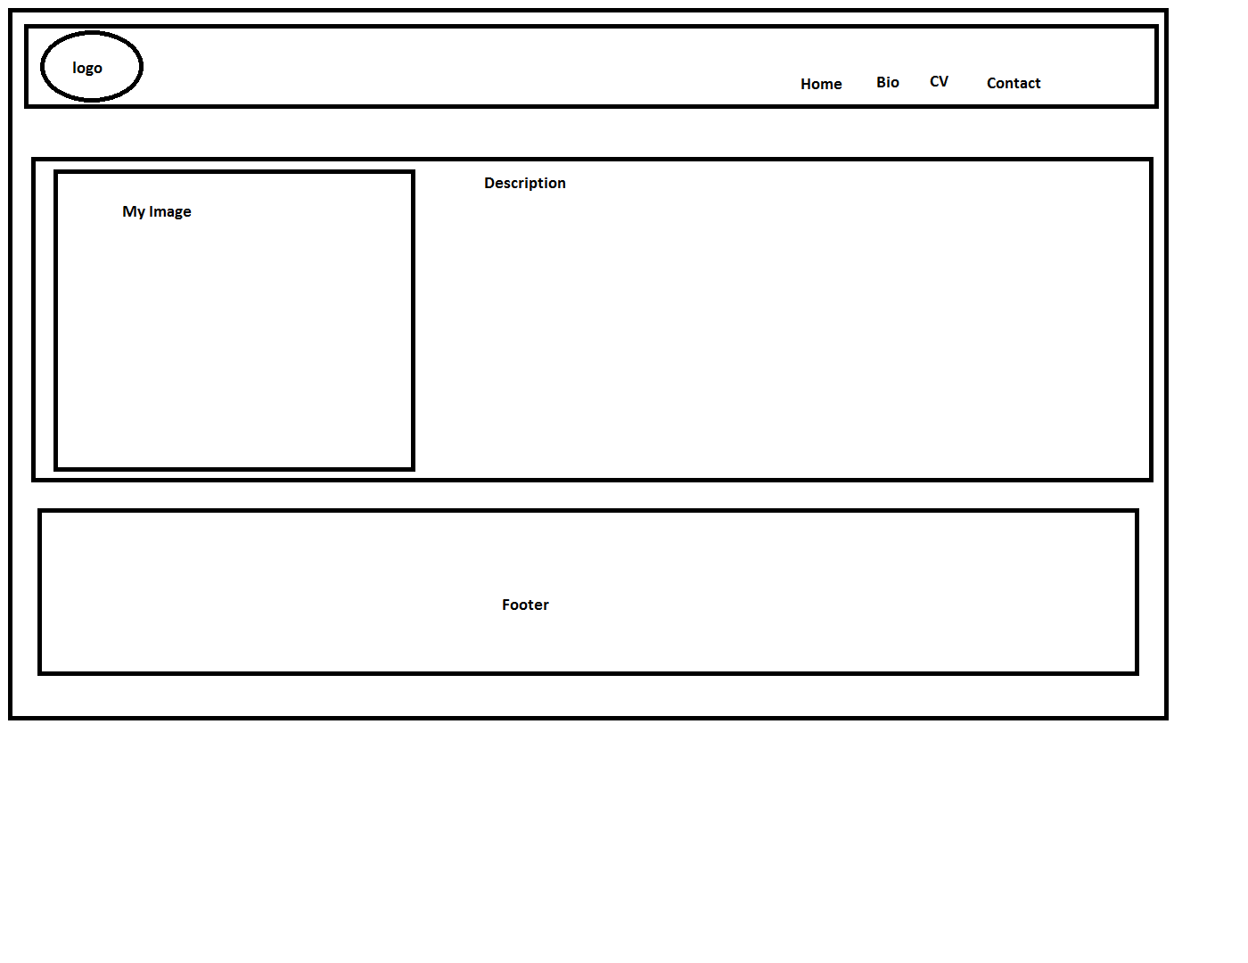

## Wireframe of Biodata.

This is the second wireframe that I design it consist of the logo and the menu bar it also consists of the body part. In the body part, there two division, one division. Finally, the footer which is at the end of the page.

Figure: The figure is wireframe of the Biodata.

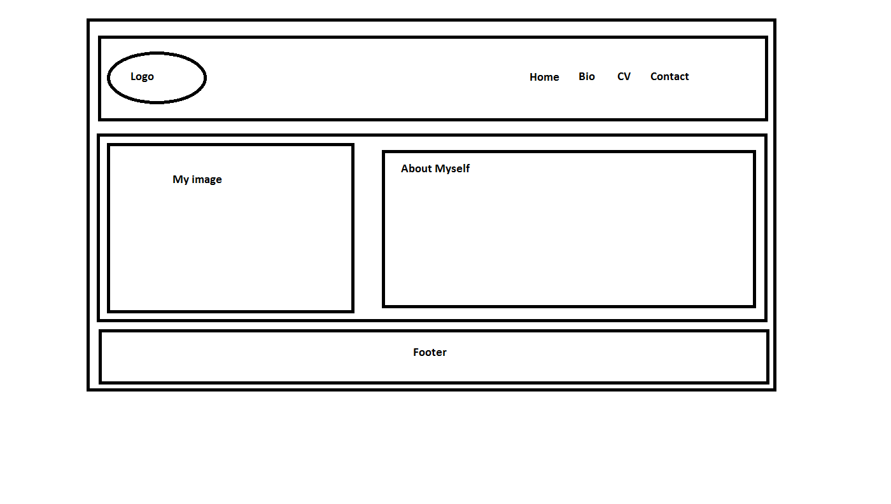

## Wireframe of CV.

This is the wireframe of the curriculum vitae which had a simple header and body section and body section consists of three division and footer

Figure: The figure is wireframe of the CV

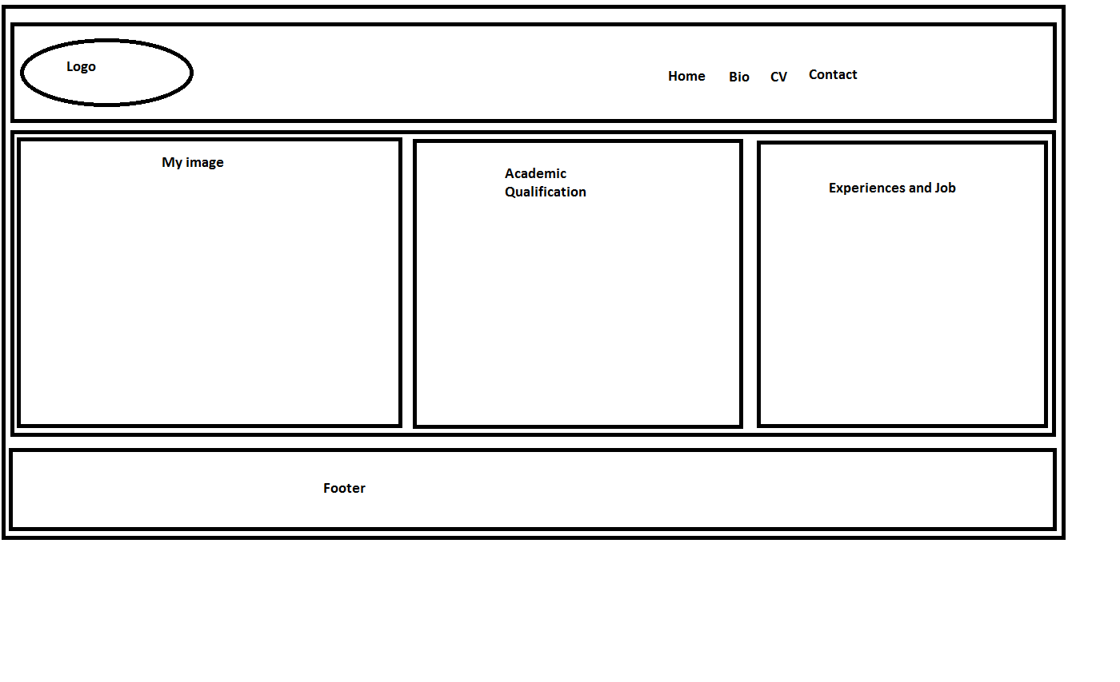

## Wireframe of Contact.

This is the wireframe of my contact page which consists of the header, body and the footer. The wireframe inside the body section consist of the two division which contain the image division and the form id division

Figure: The figure is wireframe of the Contact.

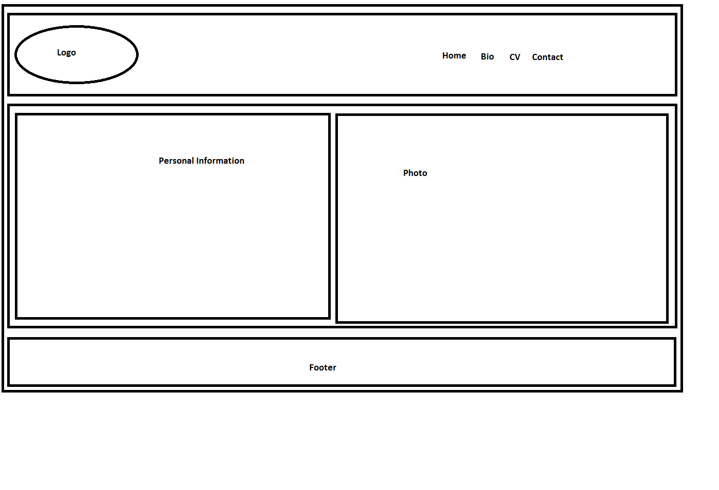

# Comparison the two websites.

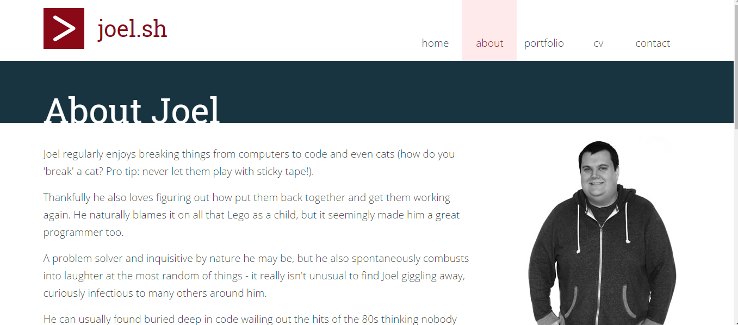

After the completion of sketches and wireframes ,two website was compared and after that real work was started to developed web by using CSS and HTML. According the example of the given in the Nile black board learning of the university the web page is also taken for the idea to developed my own portfolio. The design was also compared to another website below. The idea of the background image was strike on the mind but it was not done. 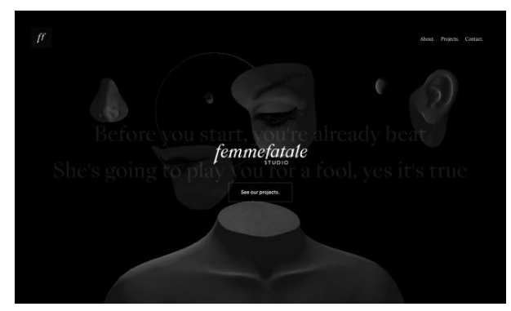

# . Progression of Website from Week 8 to Week 11.

## Week 8 (Beginning of the project work.)

Screenshot of the head part and section of index.html is shown in the picture.

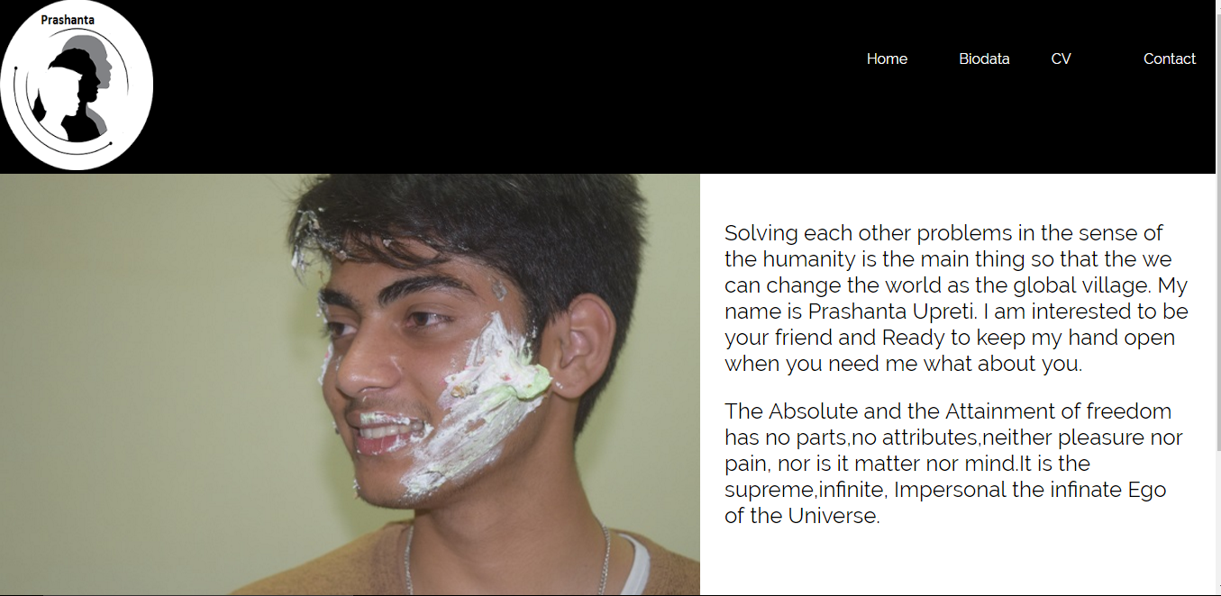

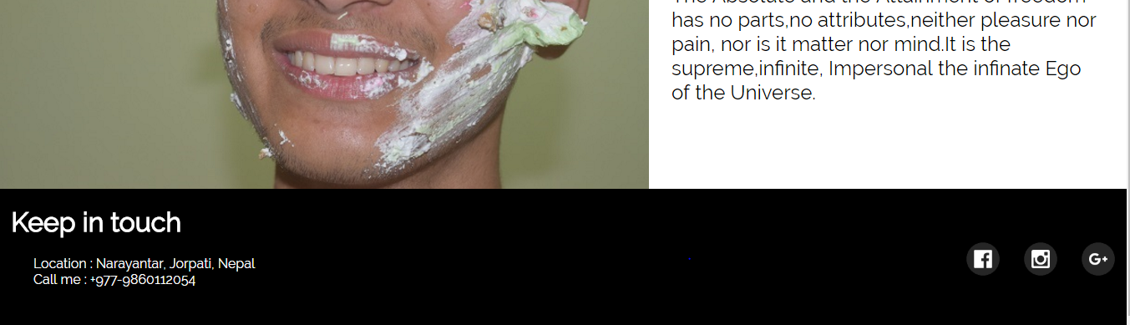

Firstly, html code was written after the design of the logo. The logo was developed from the paint. On the same way link of the CSS was also given for the website. Title was named as portfolio for the webpage after that division logo was introduced. For the logo IMGSRC tag was used to keep the logo inside the header. Secondly menu division was introduced for the navigation bar under that same header. After that section was used for the for the development of the webpage image slider was kept inside the division or div id Ganesh and after that another division sir was also created to complete the work. Another division used for the for the description of myself two paragraph was used and lies under the division name- d as text. Different type of CSS like margin, padding, font-family for the body. Header width is used, background color for the header is black. Display for the header is flex and row flex direction is given. . Menu width is used, logo. In the Section under the two-division width, padding, font size is given. Goggle font was used. Keyframe was for making image slider. Footer is developed after the completion of the body and header of index page. Firstly, the footer is divided into two division. Top and Sites are the two-division developed during development of the footer. Various type of tag is used like li, up and href is given to link to the different type of social media. For the top division, various type of CSS like width color and padding are used margin is written as zero for ul tag inside the division tag. Secondly, various type of the CSS is also used for the width and display is used as flex and flex direction is used row margin is also used. Finally, after the completion of the all thing for the index page another thing to be done is to make the website responsive @media is used to make the website responsive. For the section flex direction is used in the column and text given 100% during the responsive process. For the division media width is given and margin is given as auto. Transformation is used in the media.

## Week 9

Screenshot of the footer and section of the biodata.html page is shown in the picture.

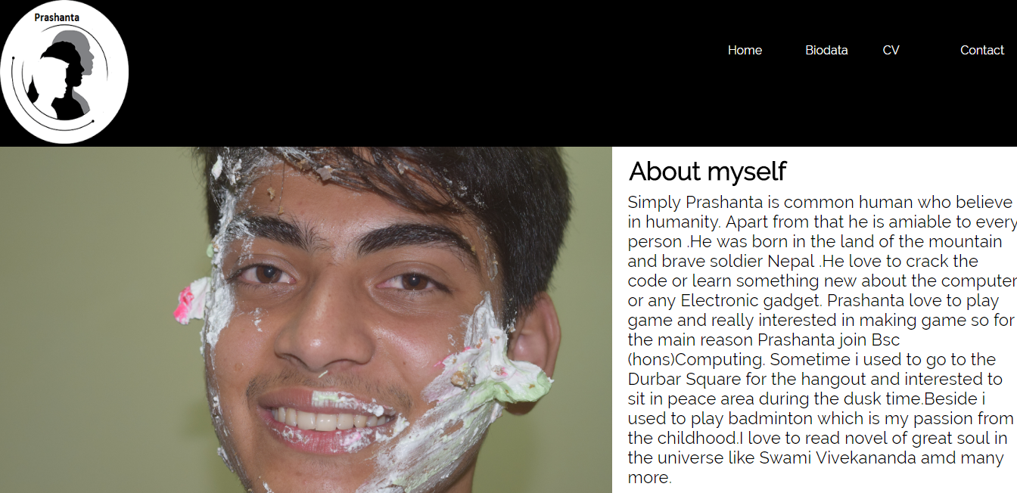

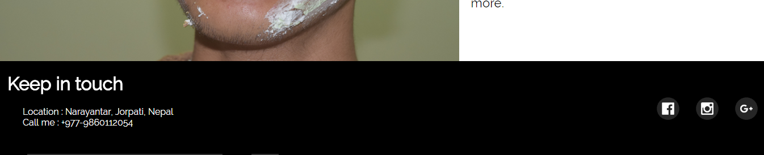

After the completion of the index page I started working on the Biodata page in this page. In the week 10 I stared to work on the same header and footer if the index webpage but section of the biodata page was changed. Two division were made inside the same section. Photo is the name of the first division and myself is the name of another division this page in section of this page. In the section of the biodata page various type of the CSS is used like width is given and display is flex and flex direction is used in the row. Inside the section for the division width is given and background color is given black and for the division myself width is given and padding is given and margin is given. In this page, same html code and CSS is used in the home page but according to need it has been changed.

## Week 10

Screenshot of the footer and section of the cv.html page is shown in the picture.

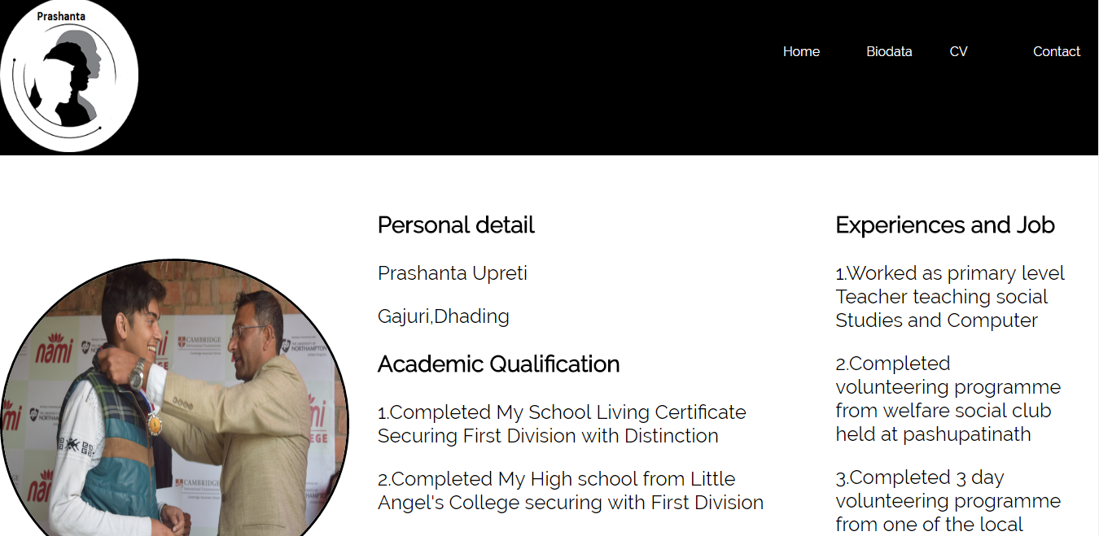

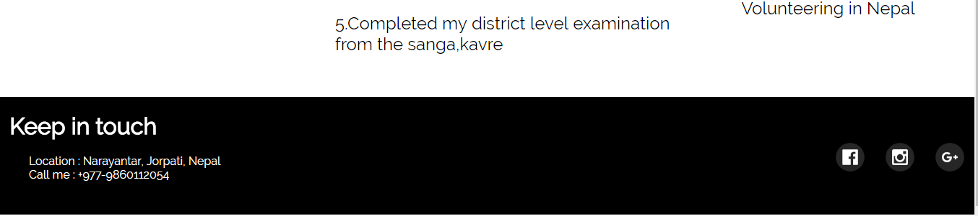During the week eleven I had completed the my cv page with the different CSS to developed the page. The section was divided into three part in this page. Note class is kept for the photo and dell class is second part in this html and book is division is used in the page. Heading or h1 tag is used to highlight the heading of the left bar. Division class is used to give the information of the experience and job. Footer is same like in the index and biodata page.

## Week 12

Screenshot of the footer and section of the contact.html page is shown in the picture.

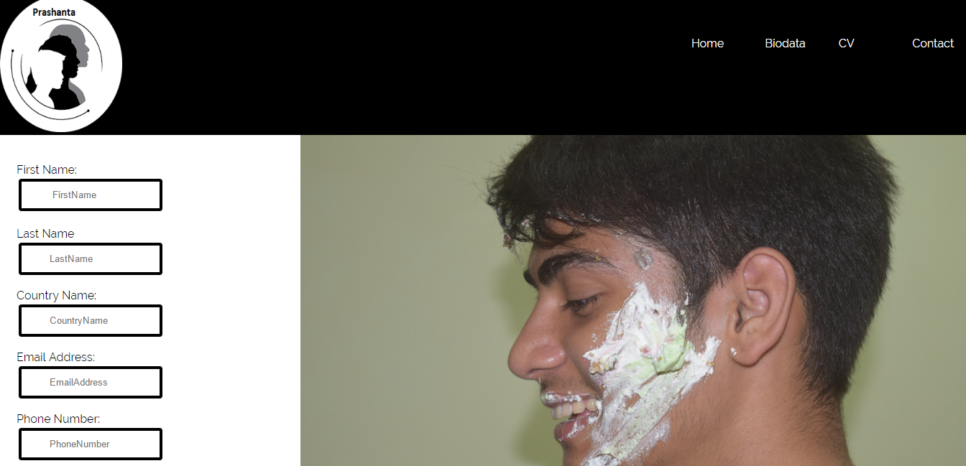

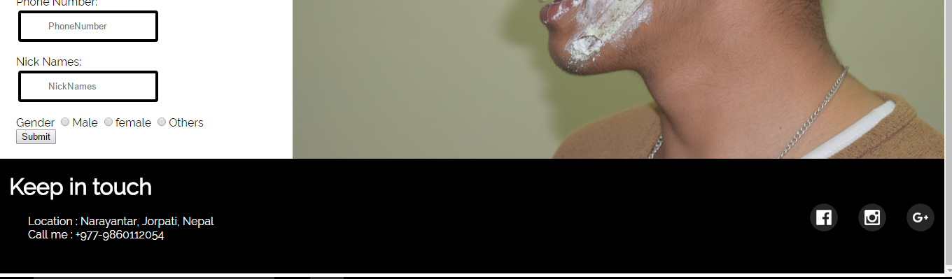

Contact page was built in the week 11 and a lot of work was done in the contact page. Input type radio is used to select the gender. Input type text is used to type the text. Label is used for the caption of the element. Paragraph tag is used for the for separate one paragraph from another. The design of the page is like the form to fill. Detail of the personal information of the person is given.CSS for the section inside the body is change. Animation is also used in the form and input type. And form was used properly.

## Week12

In this week, mobile view or making website responsive was work done by me.

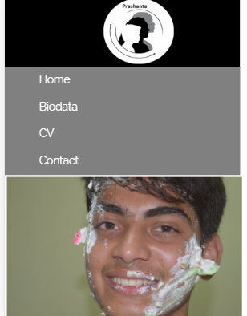 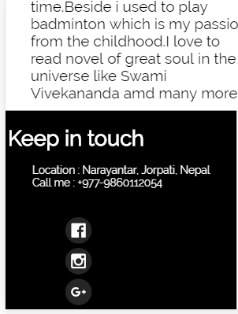

Media query is used for the making the webpage responsive in all the page like and almost flexdirection was used in the row.

# Evidence That Proves It Is Reliable website

## Page Load Speed(Website speed,2017)

Screenshot of the performance grade,load time .

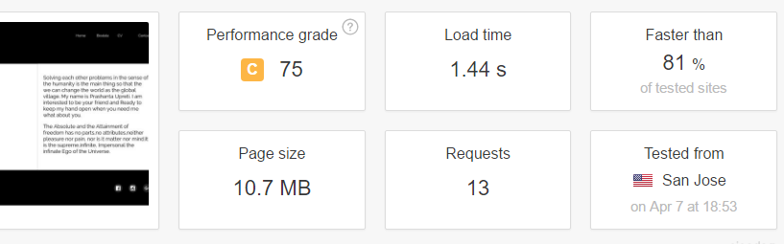

Various test has been done like performance grade is 75 and load time is 1.44s and website is faster than 81%of tested site and page size is 10.7mb.

## Prove of Html and CSS Validator(The W3C CSS,2017)

Homepage(Index)

During the checking of the home page on html validator warning is give on line 50

column9

Fig: Screenshot of the html checker for the home page

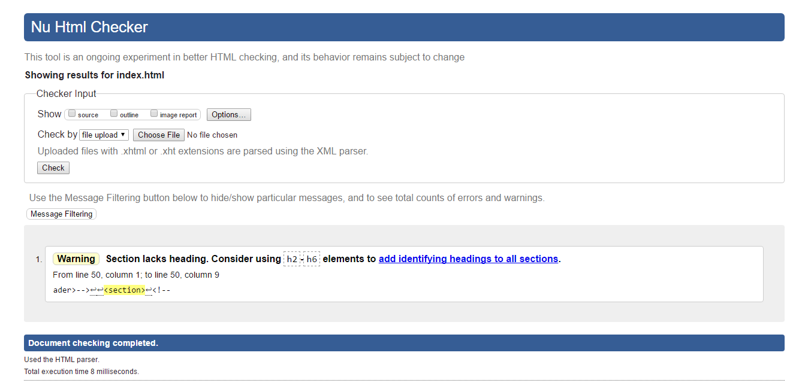

Biodata

Fig: Screenshot of the html checker for the Biodata

During the checking on the html validator from w3 school warning is given on 57 line column 4 and colunm 7.

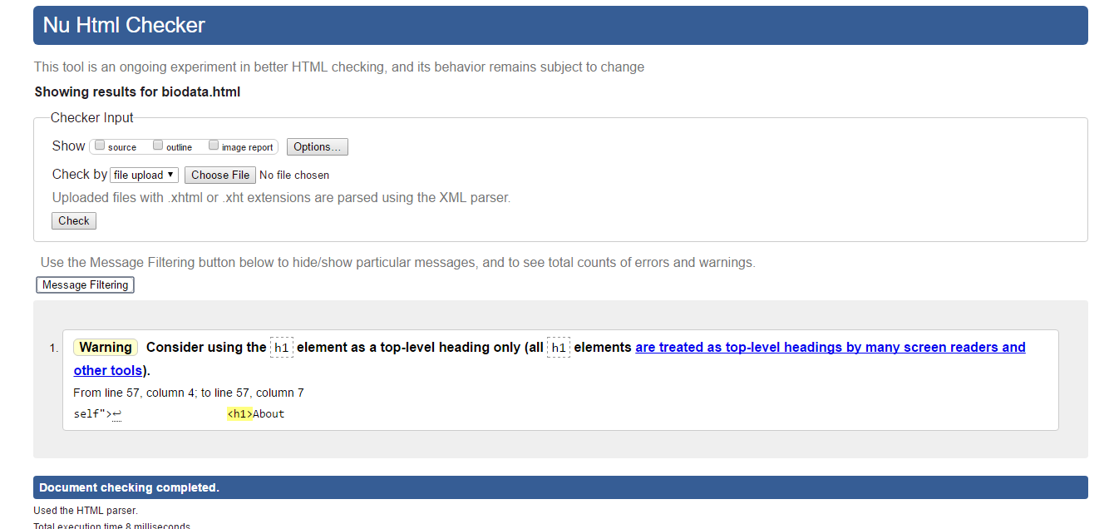

Fig: Screenshot of the html checker for the CV

While checking on the html validator four waring were given in line 61,71,85 and 50 respectively. Error was found on line 93 column1 to line 93 column10. Error was closing tag of section was repeated. Second screen is correction of error so it is related to after problem was solved.

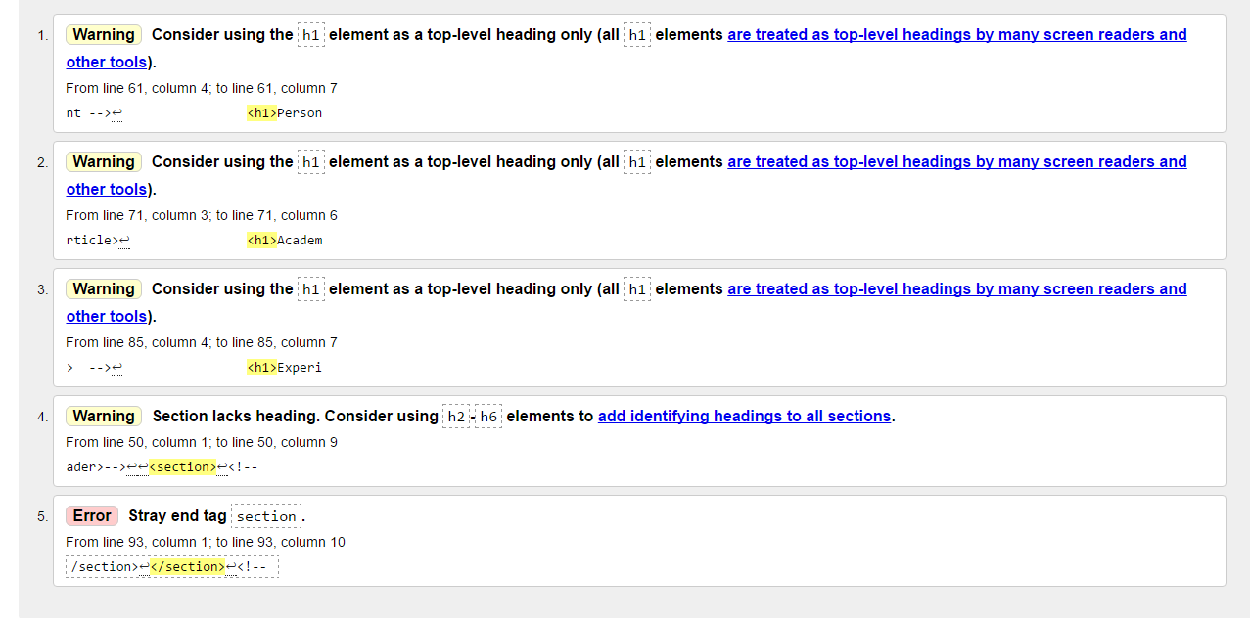

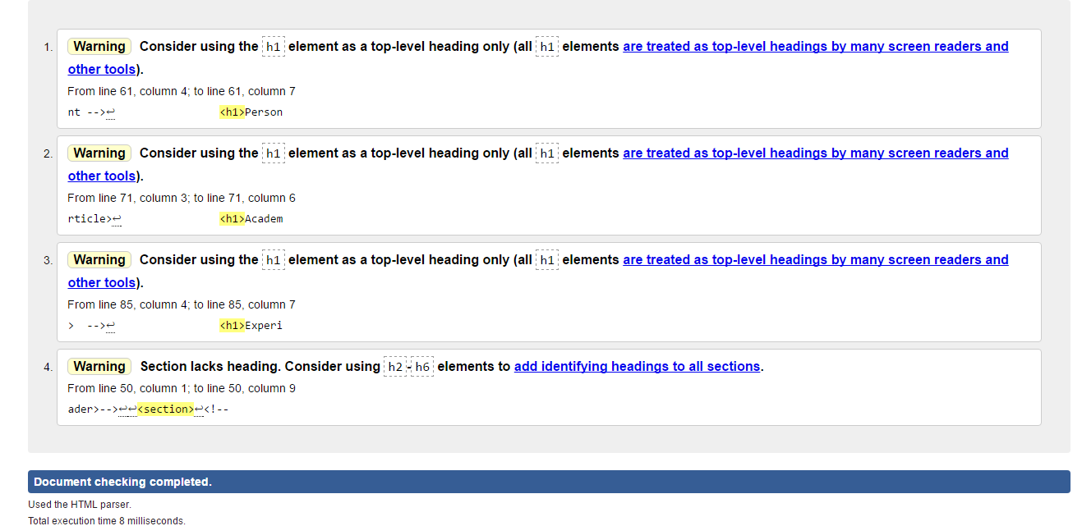

Fig: Screenshot of the html checker for the contact.

Warning was given on the line 50, column1 to line50, column9 during the checking on html validator of the of contact page.

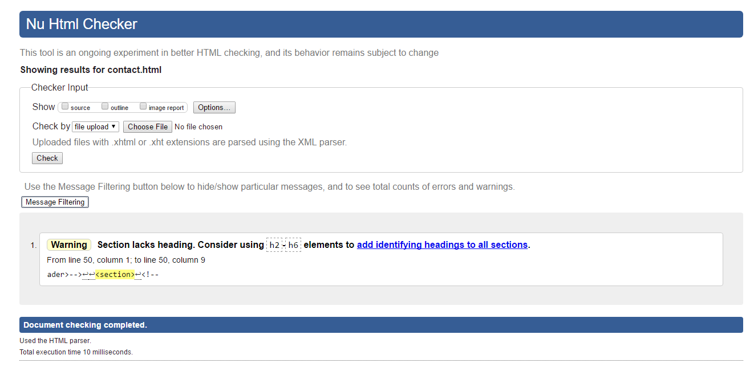

CSS validator check screenshot.

Fig: Screenshot of checking of the index.css

No error was found during the checking of the index.css and even warning is also not given.

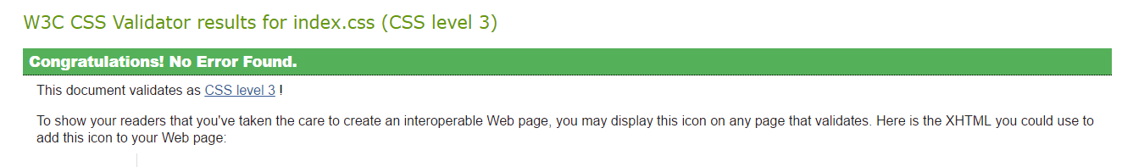

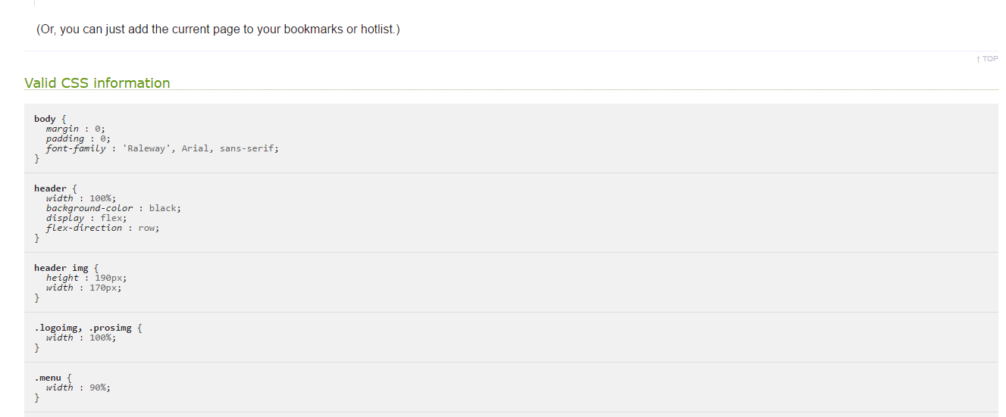

Fig: Screenshot of checking of the biodata.css

Two error was found during the checking of CSS validator in the w3school CSS validator and it was solved.

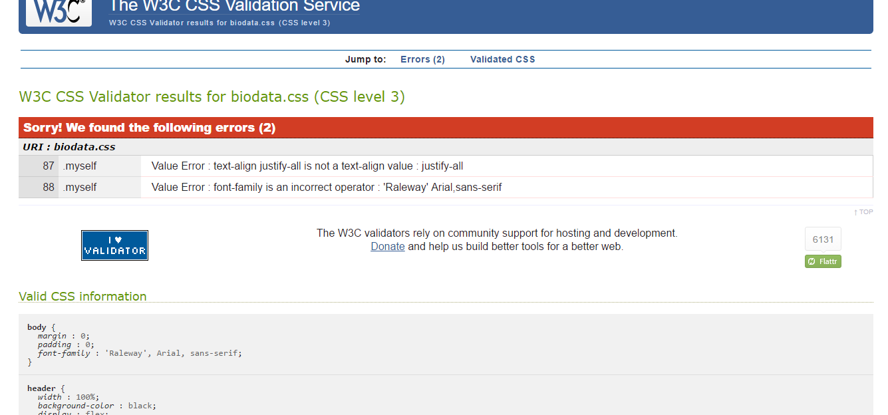

Screenshot of the solved problem of the biodata.css

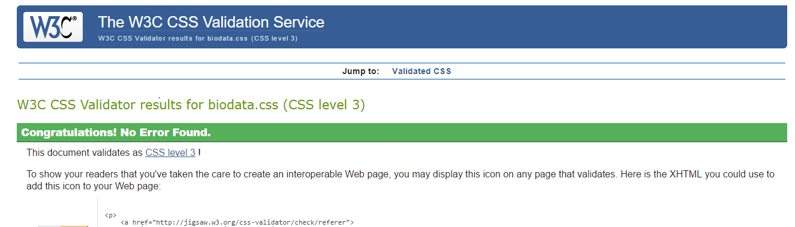

Fig: Screenshot of checking of the cv.css

No Error was found during the checking of the CSS validator in the cv page.

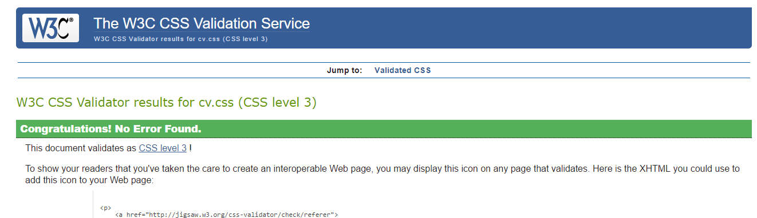

Fig: Screenshot of checking of the contact.css

One error was found that the margin of 0auto cannot be used it was managed

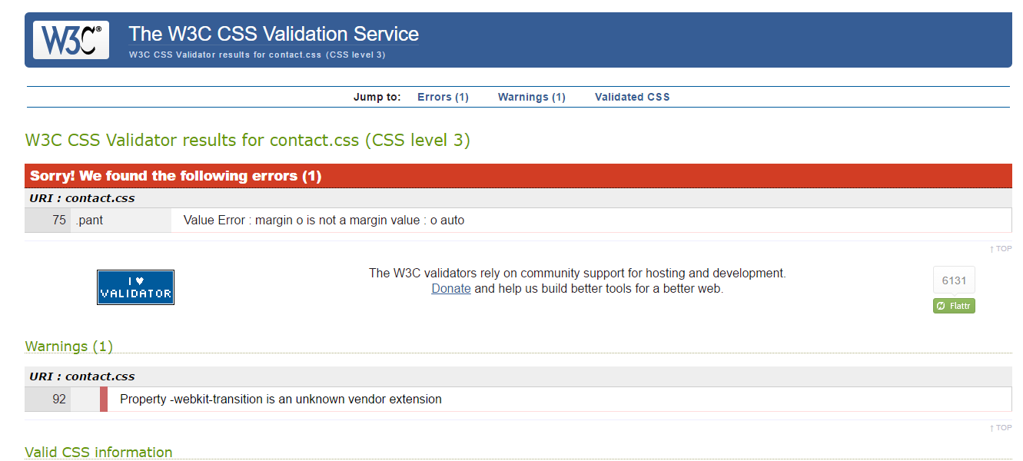

Fig: Screenshot of checking of the index.css

After the solution of the problem it was solved and no error was found.

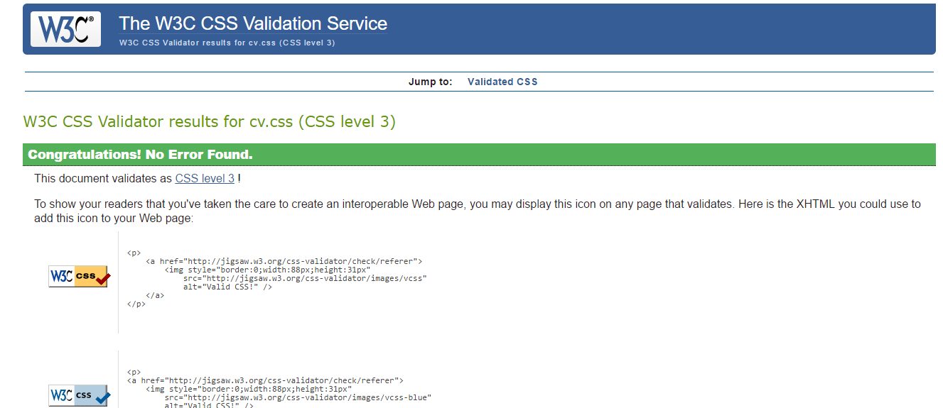

# Problems

Following are the problem faced by me during the completion of the webpage.

1.Making the webpage responsive

2.To take decision where to use transition properly.

3.One of the problem was to take decision wisely.

4.Fixing the error in the footer.

5.Main Problem was while making scroll on the down arrow came which could be solved by me even unidentified problem.

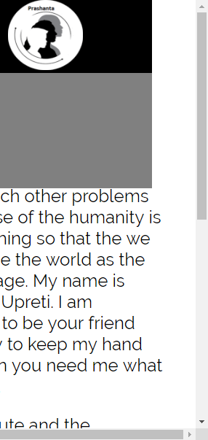

# Solution

Following point are the solution of the above problem.

1.With the help of the W3school and YouTube the problem was solved while making webpage responsive.

2.W3school example was used during the transition.

3.Simply the best was decision doing the work in the simple manner

4.W3school was used to solved most of the problem.

# Before and as per Suggestion of the Tutor.

Fig: Before the suggestion of the tutor this the screen of the webpage I created. This part is of the section and the body.

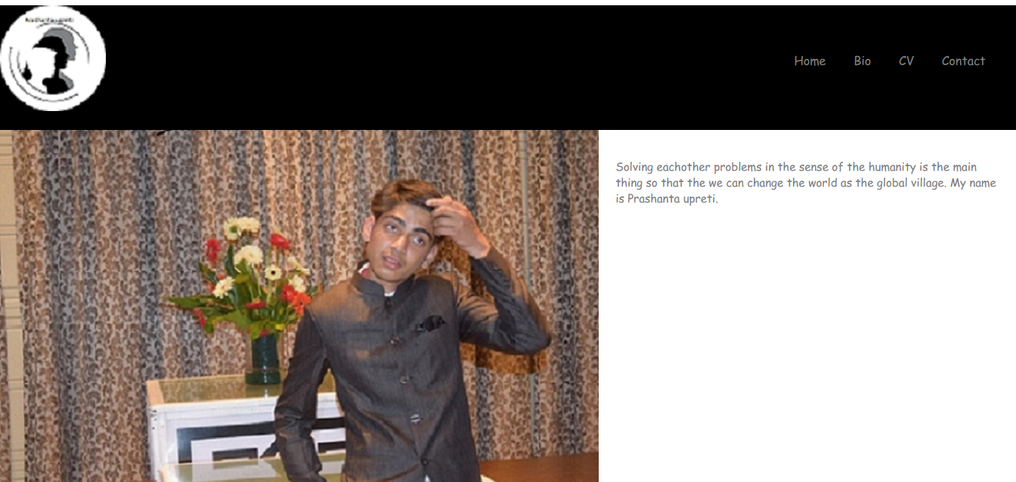

Fig: Before the suggestion of the tutor this the screen of the webpage I created.

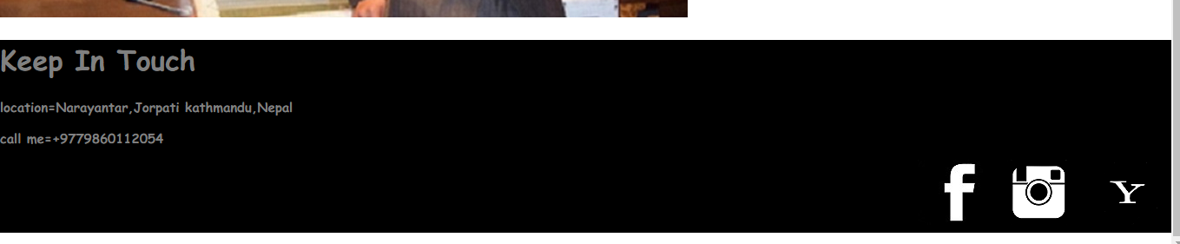

After the suggestion of the tutor.

Fig: Screenshot of my final home page after the tutor suggestion.

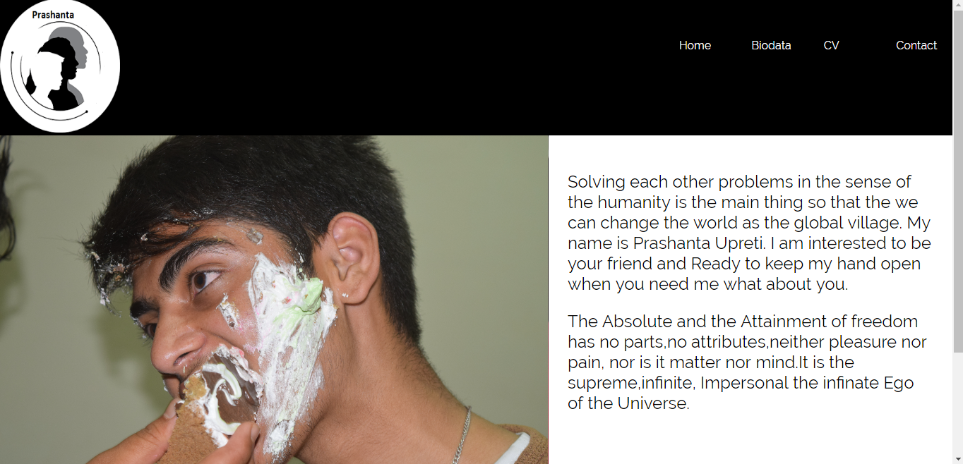

Fig: Screenshot of my final footer after the suggestion of the tutor.

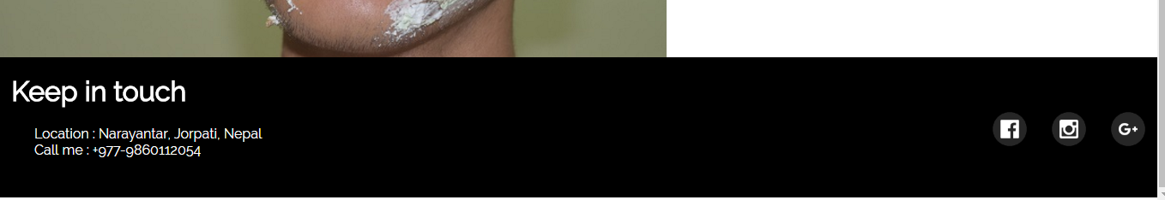

After taking suggestion from the tutor keyframe is used in the home page which make image slider. Secondly, footer was change mainly image was changed and small icon were kept at the footer. After that task when we hover the navigation bar transition was used and rotation transformation was used in the footer social media icon. Even transformation is used in the form and animation is also used in it.

# Conclusion

During the completion of the whole project some of the problem were there but it was solved with the help from the code of the w3school.The frame work was not done during the whole project work. The main problem was taking the decision to make it more simple or advanced but I choose the uncomplicated way to complete my webpage. I am very thankful for doing such project which increase my skill a lot in html and CSS. Some of problem like fixing the small error in the footer was a bit confusing. I would have fix the problem in of that thing while making the portfolio website more responsive.

# 11.References

1. Website speed test (2017) *Website speed test*. [ONLINE] Available at: <https://tools.pingdom.com/#!/cBUbd1/https://prashantaupreti2054.github.io/csy1018-assignment/>. [Accessed 03 April 2017].
2. Ready to check - Nu Html Checker (2017) Ready to check - Nu Html Checker. [ONLINE] Available at: https://validator.w3.org/nu/#file. [Accessed 02 April 2017].
3. The W3C CSS Validation Service (2017) The W3C CSS Validation Service. [ONLINE] Available at: https://jigsaw.w3.org/css-validator/. [Accessed 01 April 2017].
4. Vasiljev,V (2015) How to Create a Image Slider in CSS.*Youtube* [online]. Available from: https://www.youtube.com/watch?v=L-vBR3vzOe8 [Accessed 20th March].
5. Ready to check - Nu Html Checker (2017) Ready to check - Nu Html Checker. [ONLINE] Available at: https://validator.w3.org/nu/#file. [Accessed 03 April 2017].